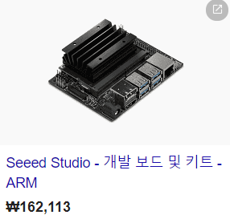 jetson nano / 162,113원
https://kr.mouser.com/ProductDetail/Seeed-Studio/102110268?qs=vLWxofP3U2x%2FN3zyzB6IPQ%3D%3D&gclid=EAIaIQobChMIzJ2pkaT45AIV06uWCh1CFwmWEAQYASABEgJRivD_BwE
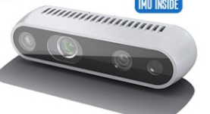Intel RealSenseD435/435i / 309,000원
http://shopping.interpark.com/product/productInfo.do?prdNo=6394784377&gclid=EAIaIQobChMI1uSK76P45AIVEj5gCh2qUQ09EAQYASABEgLW5_D_BwE
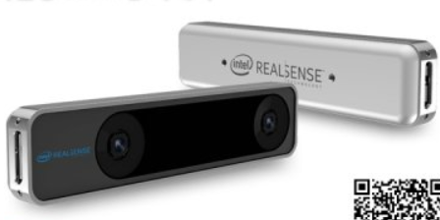 Intel RealSenseT265 / 449,490원
http://www.11st.co.kr/product/SellerProductDetail.tmall?method=getSellerProductDetail&prdNo=2365047875&gclid=EAIaIQobChMI4b-DyqT45AIVBnZgCh2q7gjmEAQYASABEgJoO_D_BwE&utm_term=&utm_campaign=%B1%B8%B1%DB%BC%EE%C7%CEPC+%C3%DF%B0%A1%C0%DB%BE%F7&utm_source=%B1%B8%B1%DB_PC_S_%BC%EE%C7%CE&utm_medium=%B0%CB%BB%F6
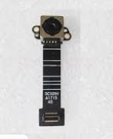integrated mipi-csi camera / 약 30 $
https://korean.alibaba.com/g/mipi-csi-camera.html

